|  |  |
| --- | --- |
|  | **Qatar University**  **College of Engineering**  **Department of Computer Science and Engineering** |

Operating Systems-(CMPS 450)

**Task: Project Phase 1**

*Fall 2024*

**Project Group Members:**

Marwan Hashish ID:201701546

Abdulla Jamali ID: 202104080

Nasser Aljufairi ID: 202005009

Murshed Al-Muhannadi ID: 201706102

**Instructor**: ***Eng.Heba Dawoud***

Task 1: SetupL Server side (VM1)

**-Create users on the server (client 1, client2)**

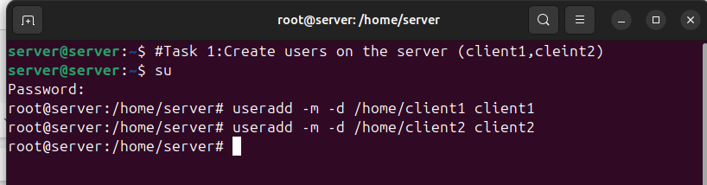-Setting passwords for client1 & client2

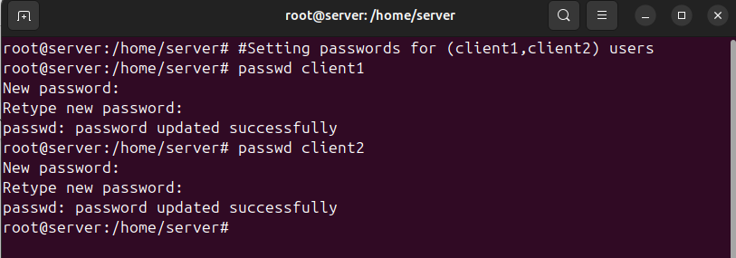-Checking that users are created (client1, client2):

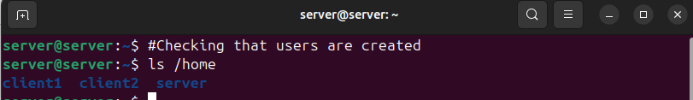

**-Install and enable SHHD**

-checking if SSH is installed

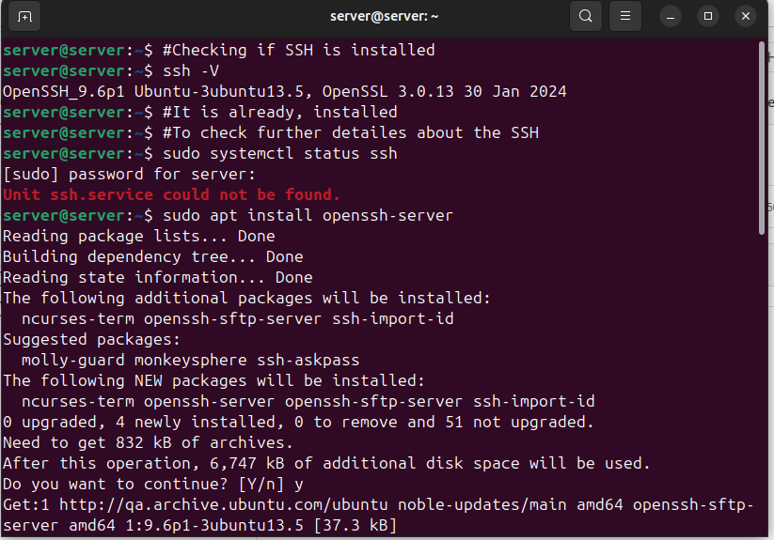-Check if SFTP is working

